Cooperative Multitasking
# Source: AI Source: Provided by: [Data Path: Persons Table -> ID Column: 1, Name_En Column: Motasem Essam] -> From: [ChatGPT] on [1/21/2026]
Cooperative Multitasking is one of the basic types of multitasking used in Operating Systems and some Real-Time Systems (RTS). It relies on tasks voluntarily giving up the CPU so other tasks can run.

Definition
# Source: AI Source: Provided by: [Data Path: Persons Table -> ID Column: 1, Name_En Column: Motasem Essam] -> From: [ChatGPT] on [1/21/2026]
Cooperative multitasking is a multitasking method where:
- Each task runs until it decides to yield (give up) the CPU.
- The operating system does NOT forcibly interrupt a running task.
- Tasks must cooperate by periodically yielding control so other tasks can execute.

How It Works
# Source: AI Source: Provided by: [Data Path: Persons Table -> ID Column: 1, Name_En Column: Motasem Essam] -> From: [ChatGPT] on [1/21/2026]
- Task A starts running.
- Task A continues executing until it calls a yield function or finishes.
- Task B runs only after Task A voluntarily releases the CPU.
- The cycle continues among all tasks.

Key Features
# Source: AI Source: Provided by: [Data Path: Persons Table -> ID Column: 1, Name_En Column: Motasem Essam] -> From: [ChatGPT] on [1/21/2026]
- No forced preemption by the scheduler.
- Tasks must explicitly yield CPU.
- Simpler to implement than preemptive multitasking.
- Requires well-behaved tasks.

Example
# Source: AI Source: Provided by: [Data Path: Persons Table -> ID Column: 1, Name_En Column: Motasem Essam] -> From: [ChatGPT] on [1/21/2026]
Suppose three tasks:
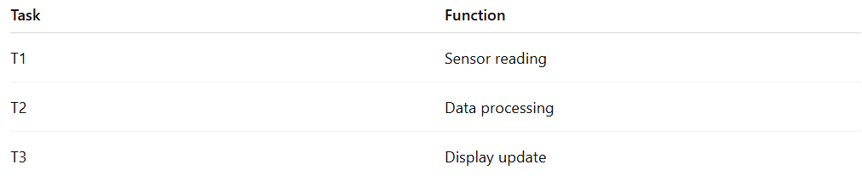
Task | Function
T1 | Sensor reading
T2 | Data processing
T3 | Display update
Execution order:
- T1 runs → calls yield() → T2 runs
- T2 runs → calls yield() → T3 runs
- T3 runs → calls yield() → back to T1
If T2 never yields, T1 and T3 will never run → system becomes unresponsive.

Advantages
# Source: AI Source: Provided by: [Data Path: Persons Table -> ID Column: 1, Name_En Column: Motasem Essam] -> From: [ChatGPT] on [1/21/2026]
- Simple and lightweight to implement.
- Low context-switching overhead.
- Predictable when tasks behave correctly.
- Useful for small embedded systems.

Disadvantages
# Source: AI Source: Provided by: [Data Path: Persons Table -> ID Column: 1, Name_En Column: Motasem Essam] -> From: [ChatGPT] on [1/21/2026]
- Poor reliability – one bad task can block the entire system.
- No guarantee that high-priority tasks run on time.
- Not suitable for hard real-time systems.
- System responsiveness depends on task cooperation.

Where It Is Used
# Source: AI Source: Provided by: [Data Path: Persons Table -> ID Column: 1, Name_En Column: Motasem Essam] -> From: [ChatGPT] on [1/21/2026]
- Early operating systems (e.g., classic Mac OS).
- Simple embedded systems with few tasks.
- Systems where tasks are trusted and controlled.

Why It Matters for Software Engineers
# Source: AI Source: Provided by: [Data Path: Persons Table -> ID Column: 1, Name_En Column: Motasem Essam] -> From: [ChatGPT] on [1/21/2026]
- Helps understand basic multitasking concepts.
- Shows the importance of task scheduling and yielding.
- Useful foundation before learning preemptive multitasking and RTOS scheduling.

